|  |
| --- |
| C:\xampp\htdocs\scroll\images\logo.png  **POLYTECHNIC SULTAN MIZAN ZAINAL ABIDIN**  **DEPARTMENT OF INFORMATION AND COMMUNICATION TECHNOLOGY** |
| **DFT 40163**  **WEB DESIGN TECHNOLOGY**   |  |  | | --- | --- | | ASSESMENT | LABORATORY TASK 2 | | NAME |  | | REG NO |  | | PROGRAMME |  | |
| INSTRUCTIONS :   1. ANSWER ALL THE QUESTIONS 2. SUBMIT THE ASSESSMENT ON _______________________________  |  |  |  | | --- | --- | --- | | **MARKING SCHEME** | | | | CLO 1P | PLO 3  P4 | / 20 | | **TOTAL** | | **/ 20** |   ***THE ENTIRE QUESTION IS BASED ON JTMK’S QUESTION BANK APPROVED BY PROGRAMME LEADER. NO SIGNATURE IS REQUIRED*** |

**CHAPTER 2 : HYPERTEXT MARKUP LANGUAGE (HTML) [CLO1]**

**Learning Outcomes:**

By the end of this lab, students should be able to:

* constructs web page using HTML

**Question**

Develop your website by using HTML codes. Your pages must runs perfectly as well as the suitability of the page as shown in Figure 1.

Figure 1: Result Page

Links :

Website : <https://arrayyanoptometry.com/>

Facebook: <https://www.facebook.com/arrayyanoptometrypaka/>

Instagram : <https://www.instagram.com/arrayyanoptometry/>

Your marks will be evaluated based on:

1. HTML Editor (4 marks)
2. HTML Basic (4 marks)
3. HTML Elements (4 marks)
4. HTML Formatting (4 marks)
5. Navigation (4 marks)

(20 marks)

**-END-**

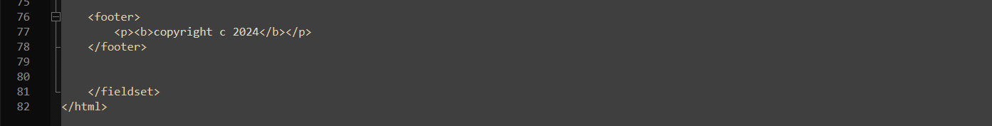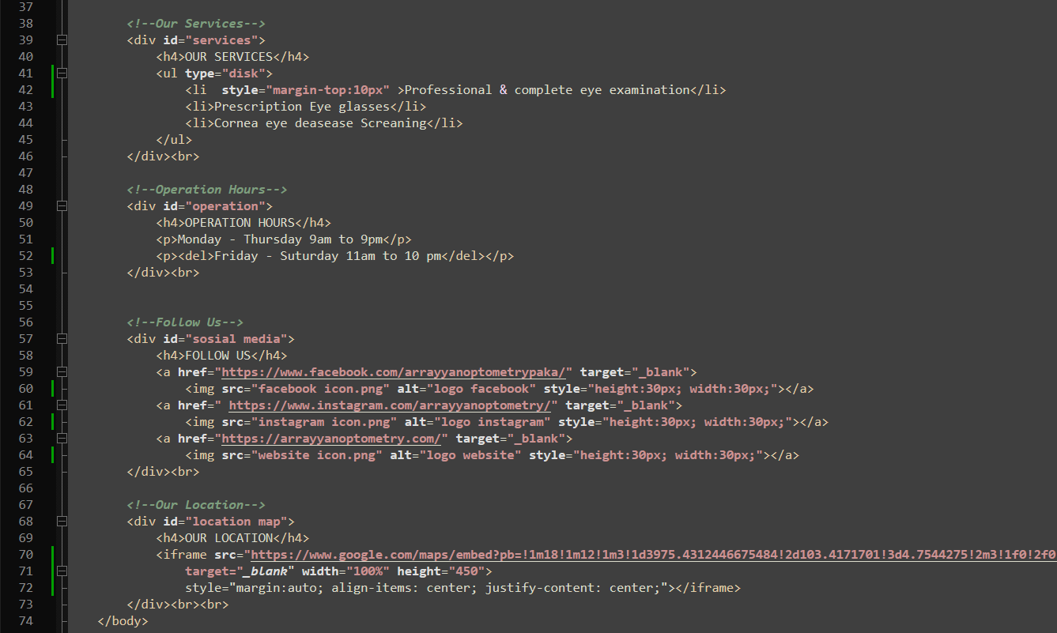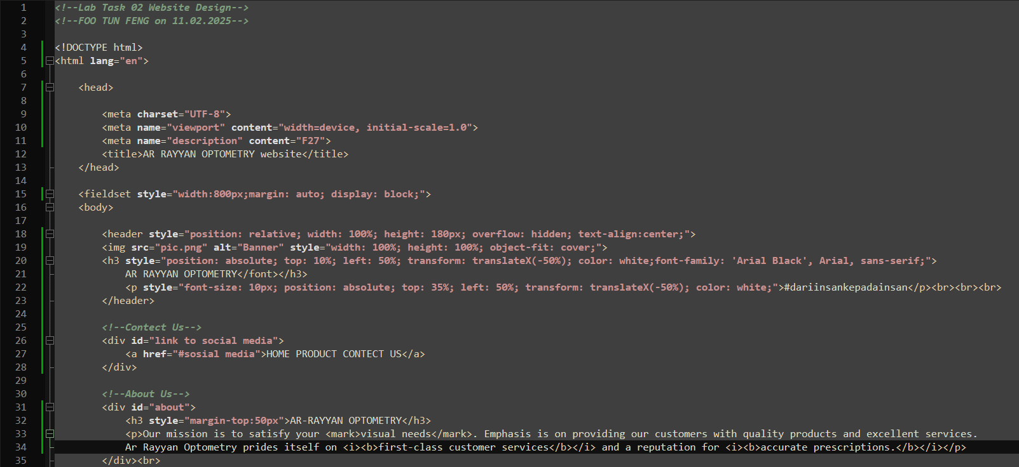**Code**

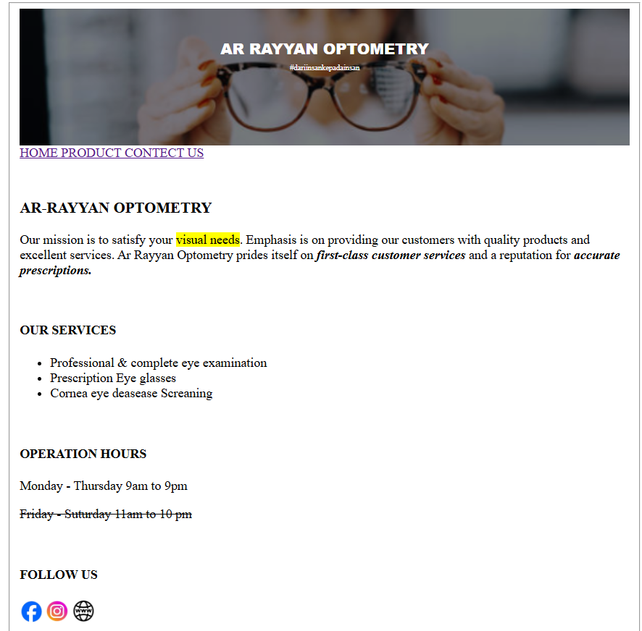**Output**

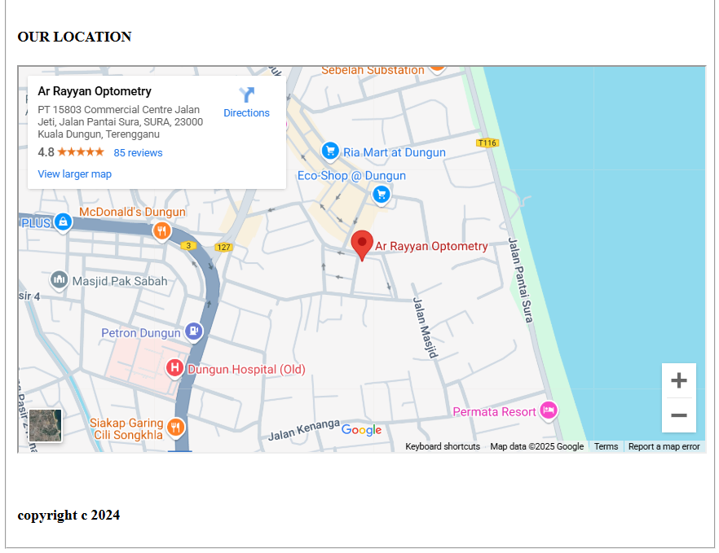

**­­­­RUBRIC FOR LABORATORY TASK 2**

**(CLO1, PLO3, P4)**

|  |  |  |  |  |  |  |  |
| --- | --- | --- | --- | --- | --- | --- | --- |
| **CRITERIA** | **(Excellent)**  **4 Marks** | **(Good)**  **3 Marks** | **(Fair)**  **2 Marks** | **(Poor)**  **1 Marks** | **Weightage (%)** | **Standard** | **Score** |
| **HTML Editor**   1. Content 2. Purpose 3. Theme | The website has a very clear purpose and theme throughout the website. | The website has a clear purpose and theme throughout the website. | The websites have fewer clear purposes and themes throughout the site. | The website has a purpose and theme that is not clear throughout the website. | 20 | Score /4 * 20 | /4 |
| **HTML Basic**   1. **Heading** 2. **Body** 3. **Paragraph** | The HTML code are well-organized; defined by a start tag, some content, and an end tag. | The HTML code are organized; defined by a start tag, some content, and an end tag. | The HTML code are somewhat organized; too many different defined a start tag, some content, and an end tag. | The HTML code are unorganized; poor defined a start tag, some content, and an end tag | 20 | Score /4 * 20 | /4 |
| **HTML Elements**   1. **Title** 2. **Image** 3. **Paragraph** | The HTML elements are easy to read, and appropriately for headings and text while maintaining a consistent tags style throughout. | Sometimes the HTML elements are easy to read, but in a few tags places are inconsistent. | The HTML elements are difficult to read and uses too many different tags. | The HTML elements are extremely difficult to read due to inappropriate use of tag. | 20 | Score /4 * 20 | /4 |
| **HTML Formatting** | HTML formatting are used to format the appearance of the text on web page in effective ways | HTML formatting are used to format the appearance of the text on web page in good quality | Inconsistent HTML formatting to format the appearance of the text on web page | Poor quality of HTML formatting to format the appearance of the text on web page | 20 | Score /4 * 20 | /4 |
| **Navigation** | All the navigation links of the website connect to the home page and/or sitemap. | Some of the navigation links website connect to the page and/or sitemap. | The navigation links of the website connect to the page and/or sitemap, but in other links. | There are significant problems with navigation links of the website and few or no connections to the page and/or sitemap. | 20 | Score /4 * 20 | /4 |
| **TOTAL SCORE** | | | | | 100 |  |  |